令和６年度

第1回全校テスト

第２学年英語科

2024/06/27

Class：＿＿＿＿＿ No.：＿＿＿＿

Name：＿＿＿＿＿＿＿＿＿＿＿＿＿＿＿

１～４の問題はリスニングテストです。英文はすべて2回繰り返します。

１．（１）～（４）の英文の内容に合う絵を，それぞれのア～エの中から１つずつ選び，その記号を書きなさい。
エ
ウ
イ
ア
（１）（１）
午後
午前
午後
午前
午後
午前
午後
午前
Alex
Alex
Alex
Alex

（２）
ア
イ
ウ


ウ
今日 明日
昨日 今日
ア
イ
昨日 今日
（３）

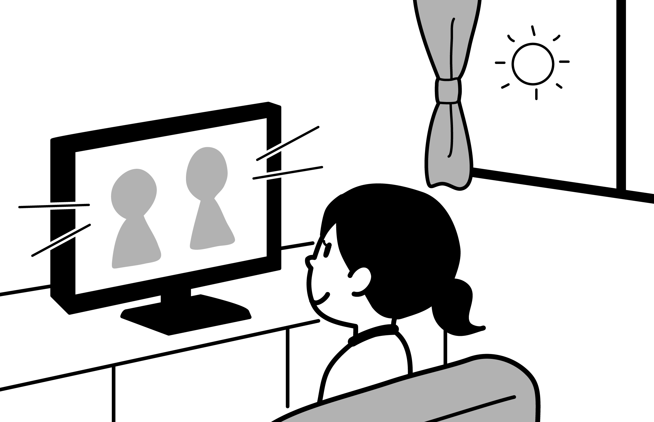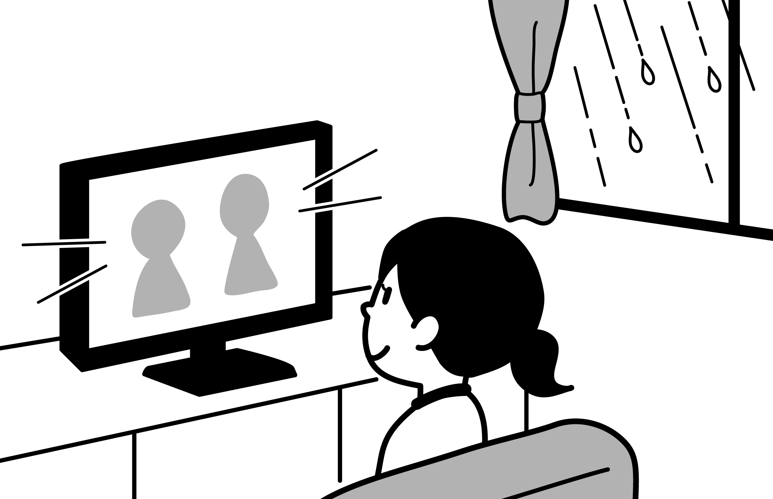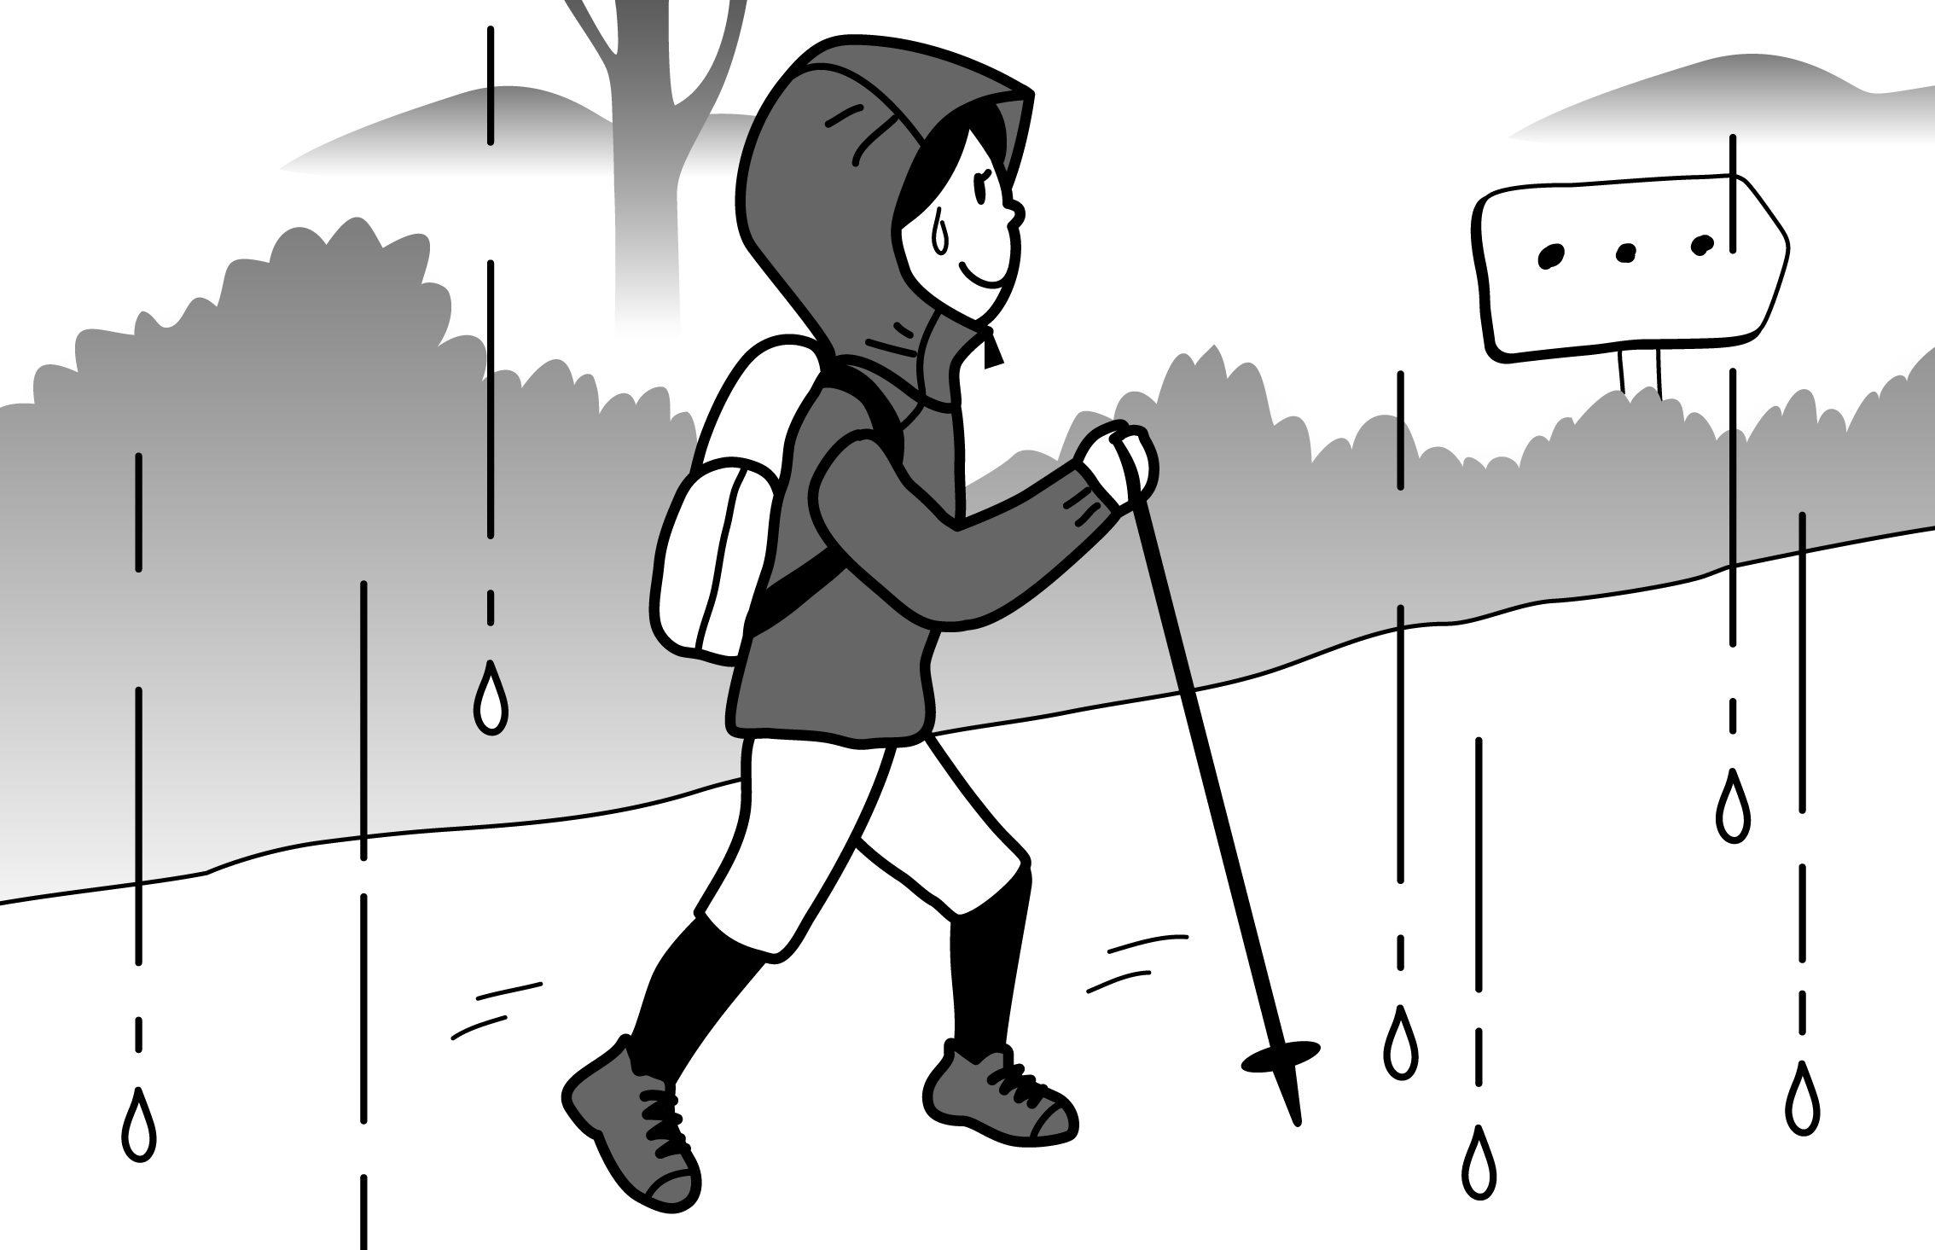（４）
ア
イ
ウ

２．ボブと真奈美(まなみ)の対話を聞いて，次の（１）～（３）の質問に対する答えを，それぞれのア～ウから１つずつ選び，その記号を書きなさい。
（１）真奈美はだれと北海道(ほっかいどう)へ行きましたか。
ア いとこ イ 妹 ウ 両親
（２）真奈美は北海道でどこを訪れましたか。
ア 時計台 イ 美術館 ウ 動物園
（３）ボブは兄と何を見ましたか。
ア おもしろい映画 イ 美しい絵 ウ かっこいい動物

3．アンが話している英文を聞いて，次の（１）～（３）がその内容に合う質問と答えになるように,（ ）内に適する英語を１語ずつ書きなさい。
（１）When are Ann and her sister going to see a movie? ― On ( ) afternoon.
（２）What is Ann going to do for her uncle on Sunday? ― She is going to ( ) ( ) for him.
（３）Will Ann and her uncle play tennis at the park? ― ( ), they ( ).

４．直也が昨日したことについて話している英文を聞いて，次の①～③の（ ）内に聞き取った英語を１語ずつ書きなさい。
Yesterday morning, I practiced the guitar at home. In the afternoon, I ( ① ) to the museum with my friend, Ann. At seven, I ( ② ) curry and rice for dinner. After that, I ( ③ ) a video game with my brother. I enjoyed the day very much.

リスニングテストは以上でおしまいです。答えは解答用紙に記入してください。

５．次の日本語の意味に合うように（ ）に適当な英語1語を書きなさい。
(1) I want to go ( ).  (2) Kaito ( ) some fossils of animals.  (3) I never ( ) of curry bread.  (4) The Merlion is 8.6 meters ( ).  (5) Sushi wasn’t ( ) in the U.S.  (6) What do you ( )? | 私は海外に行ってみたい。  海斗は動物の化石を見つけた。  カレーパンって聞いたことがなかった。  マーライオンは8.6ｍの高さがある。  アメリカでは寿司は人気がなかった。  どういう意味ですか。

６．次の英文は，Joshが読んだ本の内容をもとにまとめたスピーチの原稿です。スピーチを書く際にJoshが書いたメモをもとに英文の①～⑥に入る適切な英語を，１語で書きなさい。

Japanese Curry and Rice
I’ll tell you the ①__________ of the Japanese “curry and rice”.
In the 18th century, special curry spices ②________ to the U.K. from India. After that, a British ③__________ produced curry powder. The cooking of curry became ④___________.
In the 19th century, Japanese chefs put flour in the curry, and it became ⑤_______. They also used big pieces of potatoes, onions, and carrots. Then, they put the curry ⑥_______ rice. This became the Japanese “curry and rice.”
Joshのメモ
・日本のカレーの歴史について
・18世紀にイギリスにカレーの香辛料がインドから伝わった。
・イギリスの会社がカレー粉を製造
・カレーを作るのが簡単になった。
・19世紀に日本人のシェフが小麦粉を
入れ，どろっとしたカレーを作った。
・大きなかたまりのジャガイモや玉ねぎ，にんじんなども入れた。
・できあがったカレーをご飯にのせた。
・こうして日本のカレーライスが誕生

記事を読んだときにとったメモ

７．（ ）内の語を並びかえて、日本文にあう英文を書きなさい。問題の作成上小文字にしてある部分があるが、大文字にするべきところは大文字で書きなさい。
(1) ( call / Hiro / me / my / classmates ). 私のクラスメートは私をヒロと呼んでいます。
(2) ( a big park / near / is / my house / there ). 私の家の近くに大きな公園があります。
(3) ( P.E. / teaches / Mr. Jin / us ). 仁先生は私たちに体育を教えています。
(4) ( going / you / are / to / do / what ) this weekend? 今週末は何をする予定ですか。
(5) ( a / we / had / wonderful / time ). 私たちはすてきな時間を過ごしました。
８. (1)～(5)の英文を読んで,あとの問いに答えなさい。
(1) 前後のつながりをみて，適切な接続詞を下から選び，書きなさい。大文字にするべきところは大文字で書きなさい。
and
but
if
that
when
because
① My brother was watching TV _________ I got home.
② I think _________ English is important for us.
③ I closed the window ____________ it was too cool.
➃ _______ you are interested, I will send you a catalog.

(2) メグと海斗は交流イベントに来ています。2人の対話を読み，会話のすぐあとに海斗はどのように行動すると思いますか。最も適当なものを一つ選び，その記号を書きなさい。

Meg: I want to listen to the presentation on the main stage.
Kaito: Me, too, but can we go there later?
Meg: Why? What do you want to do now?
Kaito: I want to try some ethnic food over there.
Meg: Oh, but many people are waiting in line. We need to get to the stage.
I don’t want to be late for the presentation.
Kaito: I understand. Let’s go to the stage first.
ア エスニック・フードをあきらめて，行列が少ない店を探してみる。
イ エスニック・フードを買ってから，プレゼンテーションに行く。
ウ プレゼンテーションを見るのをやめて，エスニック・フードの店の列に並ぶ。
エ プレゼンテーションを見るためにメグとステージのところに行く。

(3) 次の英文を読んで，下の❶❷ の問いに主語と動詞のある英文で答えなさい。
Do you know about rakugo?
Rakugo is Japanese comic storytelling. A performer on a cushion plays different roles. The performer uses two props, a fan and hand towel.
Diane Kichijitsu is a rakugo performer from the U.K. So, she performs rakugo in English and Japanese. She *mixed Japanese culture and English culture. Her rakugo also shows us the fun of rakugo.

❶ What is rakugo? （４～５語で）
❷ Where is Diane Kichijitsu from? （４～５語で）

(4) 次の英文はバスガイドが，そのツアーの日程を説明している場面のものです。ツアーの日程を簡単に表しているものを一つ選び，その記号を書きなさい。
Good morning, everyone. Today, we will visit some interesting places around Green City. First, we are going to Green City Museum. You can learn about local traditional festivals there. We will stay there for two hours. Please don't take pictures inside the museum. After leaving the museum, you will have lunch at a restaurant in Green Forest Market. After lunch, please enjoy shopping in the market. The market’s original jam is very popular. It is produced by local farmers. In the afternoon, we will visit Green Forest Castle. This old castle was built about 600 years ago. You can go inside the beautiful castle and go up its tower. The tower is 30 meters tall, and you can see beautiful views from the top. You can take pictures everywhere, so enjoy taking pictures, there. Now we will soon arrive at Green City Museum. Have a nice time.

ア グリーンフォレスト城 ➡ グリーンフォレスト市場 ➡ グリーン市立博物館
イ グリーン市立博物館 ➡ グリーンフォレスト市場 ➡ グリーンフォレスト城
ウ グリーン市立博物館 ➡ グリーンフォレスト城 ➡ グリーンフォレスト市場

(5) 哲(てつ)とスティーブ（Steve）の電話でのやりとりの場面です。下の問いに答えなさい。
Tetsu : This is Tetsu. Steve, your sister’s birthday party *starts at six at your house, *right?
It’s three now.
Steve : Oh, Tetsu. Please help me. What time *will you come?
Tetsu : At four. Are you making a birthday cake now?
Steve : （ ① ） I’m looking at a *cookbook.
Tetsu : Are you just looking at the book?
Steve : （ ② ） How difficult!
Tetsu : OK. I can come *right now.
（注）start 始まる ～, right? ～ですよね。 will ～するつもりです cookbook 料理の本 right now 今すぐ

❶ ①，②の（ ）に適する文を次から１つずつ選び，記号で答えなさい。 ①( ) ②( )
ア Yes, I am. イ No, I’m not. ウ Yes, I can. エ No, I can’t.

❷ 次の(a), (b)の時刻は，それぞれ何時ですか。数字で答えなさい。
(a) パーティーが始まる時刻 （ ）時
(b) 哲が家を出ることにした時刻 （ ）時

❸ 哲はなぜ，⑵(b)の時刻に家を出ることにしたのですか。（ ）に適する日本語を書いて答えなさい。
スティーブを手伝って，彼の（ ）のための（ ）を作るため。

９．(1)～(5)の場面の表現として適切な表現を下線部に書きなさい。
(1) 宿泊先のホテルの部屋の冷房が故障していることを伝えている場面
Guest: Excuse me. I have a problem with my room.
Clerk: Oh. What’s the problem.
Guest: ❶The air conditioner ____________ ____________ . Can you check it, please?
Clerk: Certainly, we’ll check it right away. I apologize for the trouble.
Guest: Thank you.

(2) 困っている女の子を助けてあげようとしている場面
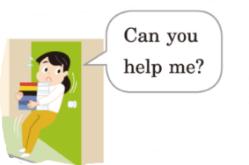
本を持った女の子 : Can you help me?
親切なあなた : OK. ❷ I ________ ___________ the door for you.
本を持った女の子： Thank you .

(3) レストランでメニューを頼んでいる場面
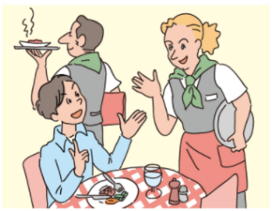
Customer: Excuse me. ❸ __________ ________ _________ _______ a menu?
Clerk : Sure. Here you are.
Customer: Thank you.

(4) 先生に許可を求めている場面
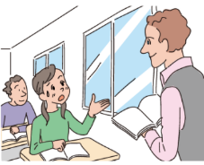
生徒: Excuse me. ❹____________ __________ ___________ the window?
It’s too hot in this room.
先生 : No problem.

(5) 図書館への道をたずねている場面
A: Excuse me. ❺ Please __________ __________ the way to the __________________.
B: Go down this street, and turn right at the second corner. You’ll see it on your left.
A: Thank you very much.

10．次の３つの質問のいずれか１つを選び，それについてあなたの立場で理由や関連する説明を付け加えて答えなさい。英文の数は問わないが，15語～30語の英文で書きなさい。

What is your favorite restaurant?
What is your favorite shop?
What is your favorite place?

解答用紙 Class: _______ No.: _______ Name: _________________________________________ Points: _________
1.  2点 | (1) | (2) |  | (3) |  | (4)
2.  2点 | (1) | (2) |  | (3)
3.  2点 | (1) |  | (2) |  | (3) |  | 思考･判断  /26
4.  2点 | ① |  | ② |  | ③
5.  2点 | (1) |  | (2) |  | (3)
 | (4) |  | (5) |  | (6)
6.  2点 | ① |  | ② |  | ③
 | ➃ |  | ⑤ |  | ⑥
7.  2点 | (1)  .
(2)
.
(3)
.
 | (4)  this weekend? |  |  |  |  |  | 知識･技能  /34
(5)
.
8.  2点 | (1)① |  |  | (1)②
 | (1)③ |  |  | (1)➃
 | (2)
 | (3)❶
 | (3)❷
 | (4)
 | (5)❶① | (5)❶② |  | (5)❷(a)  時 |  | (5)❷(b)  時 | 思考･判断  /26
(5)❸
スティーブを手伝って，彼の（ ）のための（ ）を作るため。
9.  2点 | ❶ The air conditioner ______________ _________________.
 | ❷ I _____________ ________________ the door for you.
 | ❸ __________ _________ _________ ___________ a menu?
 | ❹ __________ _________ ______________ the window?
 | ❺ Please _________ ________ the way to the _________________.
10.
4点
思考･表現

/14
リスニングテスト原稿
１～４の問題はリスニングテストです。英文はすべて2回繰り返します。

１．（１）～（４）の英文の内容に合う絵を，それぞれのア～エの中から１つずつ選び，その記号を書きなさい。
エ
ウ
イ
ア
（１）（１）
午後
午前
午後
午前
午後
午前
午後
午前
Alex
Alex
Alex
Alex

（２）
ア
イ
ウ

ウ
今日 明日
昨日 今日
ア
イ
昨日 今日
（３）

（４）
ア
イ
ウ

（１）A: What did you do yesterday morning, Alex?
B: I watched TV. In the afternoon, I went shopping
（２）A: Were you running in the park at four yesterday?
B: No, I wasn’t. I was playing the guitar at home then.
（３）It was sunny yesterday, but it will be snowy today.
（４）If it’s rainy on the weekend, Misa will watch TV at home. If it’s sunny, she will climb a mountain.

. 解答：（１）イ （２）ウ （３）ア （４）イ

２．ボブと真奈美(まなみ)の対話を聞いて，次の（１）～（３）の質問に対する答えを，それぞれのア～ウから１つずつ選び，その記号を書きなさい。
（１）真奈美はだれと北海道(ほっかいどう)へ行きましたか。
ア いとこ イ 妹 ウ 両親
（２）真奈美は北海道でどこを訪れましたか。
ア 時計台 イ 美術館 ウ 動物園
（３）ボブは兄と何を見ましたか。
ア おもしろい映画 イ 美しい絵 ウ かっこいい動物

Bob: How was your weekend, Manami?
Manami: It was great, Bob. I went to Hokkaido with my cousin.
Bob: Oh, really? Did you visit Asahiyama Zoo?
Manami: Yes. We visited there. The animals were very cool.
Bob: Great. You enjoyed your weekend.
Manami: Yes, very much. Bob, how about you?
Bob: I went to a museum with my brother. We looked at beautiful pictures.
Manami: That’s good.

解答：（１）ア （２）ウ （３）イ

3．アンが話している英文を聞いて，次の（１）～（３）がその内容に合う質問と答えになるように,（ ）内に適する英語を１語ずつ書きなさい。
（１）When are Ann and her sister going to see a movie? ― On ( ) afternoon.
（２）What is Ann going to do for her uncle on Sunday? ― She is going to ( ) ( ) for him.
（３）Will Ann and her uncle play tennis at the park? ― ( ), they ( ).

I’m going to do my homework on Saturday morning. In the afternoon, I’m going to see a movie with my sister. On Sunday morning, I’m going to visit my uncle and make lunch for him. We will eat lunch together. After that, we will play tennis at the park.

解答：（１）Saturday （２）make lunch （３）Yes / will

４．直也が昨日したことについて話している英文を聞いて，次の①～③の（ ）内に聞き取った英語を１語ずつ書きなさい。
Yesterday morning, I practiced the guitar at home. In the afternoon, I ( ① ) to the museum with my friend, Ann. At seven, I ( ② ) curry and rice for dinner. After that, I ( ③ ) a video game with my brother. I enjoyed the day very much.

Yesterday morning, I practiced the guitar at home. In the afternoon, I went to the museum with my friend, Ann. At seven, I ate curry and rice for dinner. After that, I played a video game with my brother. I enjoyed the day very much.

解答：① went ② ate ③ played

リスニングテストは以上でおしまいです。答えは解答用紙に記入してください。

